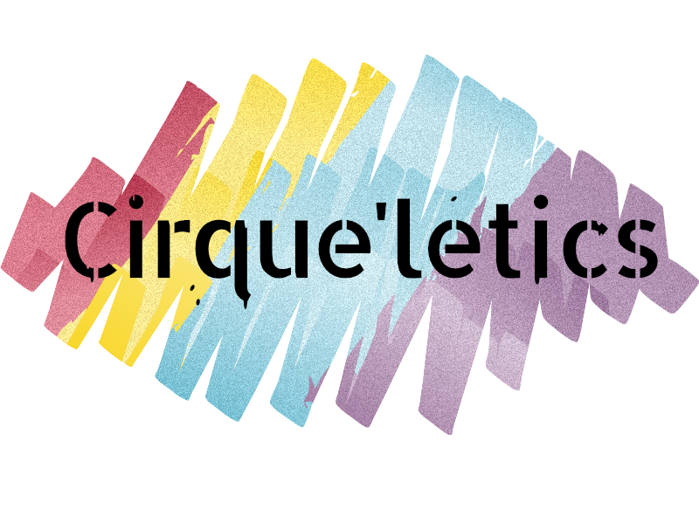

PARTICIPANT AGREEMENT, RELEASE AND ASSUMPTION OF RISK
In consideration of Cirque'letics, her agents, owners, officers, individuals teachers, coaches, landlord, building proprietor, volunteers, fellow participants, visitors and all other persons/entities acting in any capacity on their behalf or in conjunction (hereinafter collectively referred to as Cirque'letics) I hereby agree to release, indemnify, and discharge, on behalf of myself, my spouse, my children, my parents, my heirs, assigns, personal representative and estate as follows:
1. I acknowledge that my participation in a circus and acrobatics entails known and unanticipated risks that could result in physical or emotional injury, paralysis, death, or damage to myself, to property, or to third parties. I understand that such risks simply cannot be eliminated without jeopardizing the essential qualities of the activities.
The risks include, among other things: exposing its participants to the potential for: slips and falls and falling; rope burns; pinches, scrapes, twists and jolts that could result in scratches, bruises, sprains, lacerations, fractures, concussions, or even more severe life threatening hazards. In any event, if you or your child is injured, you or your child may require medical assistance, at your own expense.
Furthermore volunteers, coaches or individuals teaching private lessons have difficult jobs to perform. They seek safety, but they are not infallible. They might be unaware of a participant's fitness or abilities. They might misjudge the weather or other environmental conditions. They may give incomplete warnings or instructions, and the equipment being used might malfunction.
- I expressly agree and promise to accept and assume all of the risks existing in these activities. My participation at this location is purely voluntary, and I elect to participate in spite of the risks
- I hereby voluntarily release, forever discharge, and agree to indemnify and hold harmless Cirque'letics from any and all claims, demands, or causes of action, which are in any way connected with my participation in this activity or my use of the companys equipment or facilities, including any such claims which allege negligent acts or omissions of the staff, volunteers, coaches, management and or facility owner/operators.
- Should Cirque'letics or anyone acting on their behalf, be required to incur attorney's fees and costs to enforce this agreement, I agree to indemnify and hold them harmless for all such fees and costs.
- I certify that I have adequate insurance to cover any injury or damage I may cause or suffer while participating, or else I agree to bear the costs of such injury or damage myself. I further certify that I am willing to assume the risk of any medical or physical condition I may have.
- In the event that I file a lawsuit against Cirque'letics, I agree to do so solely in the province of Newfoundland, and I further agree that the substantive law of that province shall apply in that action without regard to the conflict of law rules of that Provence. I agree that if any portion of this agreement is found to be void or unenforceable, the remaining document shall remain in full force and effect.
By signing this document, I acknowledge that if anyone is hurt or property is damaged during my participation at this location, I may be found by a court of law to have waived my right to maintain a lawsuit against Cirque'letics on the basis of any claim from which I have released them herein.
- Publicity &Photo Release: I hereby grant to Cirque'letics the absolute and irrevocable right and unrestricted permission to use my name and that of my child, our likeness, image, voice, and/or appearance as such may be embodied in any photos, video recordings, audiotapes, digital images, and the like, taken or made on behalf of Cirque'letics. I agree that Cirque'letics has complete ownership of such material and can use said material for any purpose consistent with their missions. These uses include, but are not limited to, videos, publications, advertisements, news releases, Internet sites, and any promotional or educational materials in any medium. I acknowledge that neither I nor my child will receive any compensation for the use of such images, video, likeness, etc

- I am aware that there are risks with circus arts, I warrant that the participant named on this information form, is physically fit to participate in circus arts. I acknowledge that there is potential risk for injury involved in circus arts. I understand that Cirque'letics has tried to create a safe and controlled environment for participation and that the gym established rules for participation that must be followed by the participant at all times. I waive the rights of the participant to damages or other costs in the event injury is caused due to participation in circus or other involvement with the program. (Please ask for clarification regarding waiver if necessary)
I have had sufficient opportunity to read this entire document. I have read and understood it, and I agree to be bound by its terms.

Signature of Participant ____________________________________ Date ______________Print Name___________________

Address____________________________________________________________________________________

_____________________________________________________________________ Phone ________________________

Email ________________________________________

PARENT'S OR GUARDIAN'S ADDITIONAL INDEMNIFICATION (Must be completed for participants under the age of 18)

In consideration of _____________________(print minor's name) ("Minor") being permitted by ____________________to participate in its activities and to use its equipment and facilities, I further agree to indemnify and hold harmless Cirque'letics from any and all claims which are brought by, or on behalf of Minor, and which are in any way connected with such use or participation by Minor.

Parent or Guardian Signature _______________________________ Date _______________

Print Name ____________________________________________

Address _____________________________________________________________________

Phone_______________________________________________________________________

Email _______________________________________________________________________

Emergency Medical Information:
________________________________________________________________________________________________________

